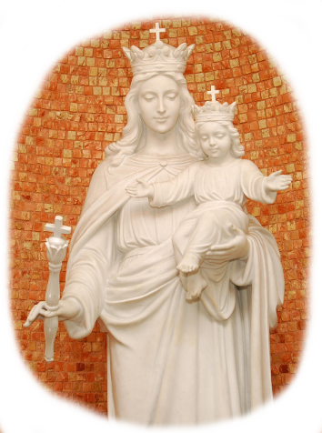
Preparation for the feast of Mary Help of Christians
Fr. Ángel Fernández Artime

My dear friends,
Warm, affectionate greetings! I’m writing to you in the immediate preparation for the feast of Mary Help of Christians, and I’m asking Jesus’ mother to obtain God’s blessing on all of you, with my best wishes for your families and the persons and situations who need more light.
In these first months, I’ve begun to visit some of the provinces, and I’m getting to know better the reality of the Congregation and the whole Salesian Family. I thank God for the good that’s carried out all over the world in Don Bosco’s name on behalf of the young, of the poorest, and of ordinary people. They’re evidence of the multitude of exciting projects where God, with a few loaves and a few fish, constantly multiplies our action and causes the poor works of our hands to blossom.
I’m very happy to share with you my hopes and desires. I’m available to you to continue to offer some impetus and sustain with my presence, my humble service, and my prayer whatever the Spirit is stirring up in our provinces.
We’re presently in the Easter season, and the peace of our Risen Savior gladdens our hearts. His message of life and fulfillment brings great joy to our countenance and makes our eyes shine, for they can contemplate a new horizon for all of humanity. The future is God’s, and we anticipate it every day by devoting ourselves to throwing open the prisons of injustice, by heartening those who are prey to discouragement, by sustaining those who walk with difficulty, by sharing who we are with those who have less or are alone.
This is the message of the One who lives: new life according to God’s heart, the dignity of his children, a promising future for the little and the poor. As St. Irenaeus wrote so long ago, “The glory of God is man fully alive.” This is our commitment too: to give glory to God in our brothers and sisters who are most in need.
Just in these days we’ve received awful news of the persecution of Christians in many parts of the world, of violations of human rights in critical areas of the planet, of the mistreatment and kidnapping of minors on account of their being female or of their religion. Nothing is further from God’s plan! The presence of the Risen Lord lights up the darkness; he is peace that melts away fear. The message of Christ our Savior is one of harmony in a new creation set free from evil and darkness. Unfortunately, sin clutches at us, and darnel chokes the good grain. Hence we Christians, with men and women of good will, in the name of God and of our most vulnerable brothers, must continue to strive to bring forth a new reality that’s closer to God’s plan with more opportunity for everyone, in which, in the time of “already but not yet,” more strongly resounds the fullness of the new creation that still groans in labor pains.
We must raise our voice and join in the prophetic declaration that the Holy Father has raised in these days, asking the powerful not to remain indifferent and to join forces to bring an end to cruelty and injustice.
Nevertheless, we’re not dealing only with a political matter for states or with strategies for the United Nations. In our Salesian Family, marked by a deeply paschal spirituality, we shall continue to work with all our power that there may be ever more life, in Jesus’ name, for the little and the least. With the heart of the Good Shepherd, who cares for the weakest ones, we shall pursue sound options to carry out for young people most ill-favored and at risk, as Don Bosco taught us and wishes us to do.
The call of Francis to emphasize a “Church that goes out” to the peripheries and poor neighborhoods where suffering and discouragement are greater is a stimulus for our undertaking of educating and evangelizing. We’re called to a new way of “being pastors”: it’s the revolution of gentleness, of bending down to those who are hurting the most, of welcoming those who are far away, of making a way for those who are last, of accompanying personally those whom social realities shove aside and abandon.
My dear friends, this is our undertaking too.
In these years we’ll continue to work, as part of the whole Church, to make our way of life more credible, to make our proclamation bolder. This will happen insofar as our choices are closer to the needs of the poorest young people. Our last general chapter has asked the Salesians to increase the witness we give of living the Gospel in a radical manner. The invitation can be extended to the whole Salesian Family. To follow Jesus is to walk on the road of poverty and closeness to the last in society. Like the Master, we want to pass amid humanity, healing and liberating. Those who bear Christ’s wounds imprinted in the flesh of their own tortured existence are the people to whom the Risen Lord addresses first of all his message, “Peace be with you!”
As we approach the bicentennial of Don Bosco’s birth, the best way to celebrate our Father is faithfulness to his great intuitions. I don’t doubt in the least that one of these, a vital commitment for him as well as for us today, is the preferential option for “abandoned and endangered” youths.
The message of the Risen Lord, to return to Galilee, means for us to return to our roots, to return to poor young people. I’m sure that “we shall meet him there.”
Cordially yours in Don Bosco,
Fr. Angel Fernandez Artime
Rector Major

